May 31, 2020

Dear Parent(s)/Guardian(s),

I want to personally thank our Holy Spirit community for their support in our food drive for the Aurora Food Pantry. The pantry was overjoyed with the support we were able to provide them during a time that has become difficult for some of us in our community. I would also like to thank the communities of St. Jerome CES and Light of Christ CES for their donations to the food pantry as we showed a great team effort in supporting those who need it most. Please see below for some important school information.

Food Drive Reminder
Here are some pictures of the fantastic spirit our school community and partners showed in supporting the Aurora Food Pantry.
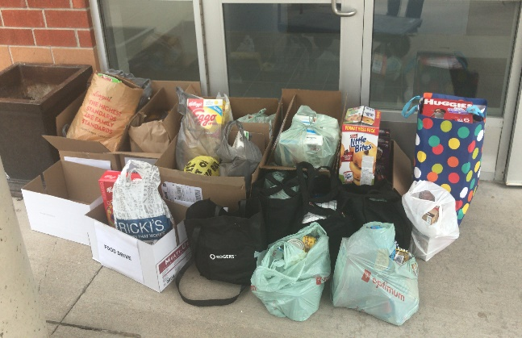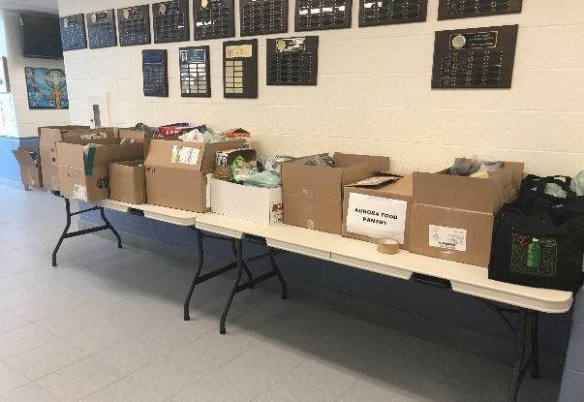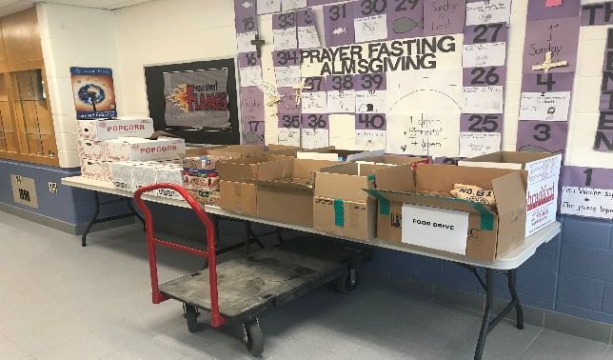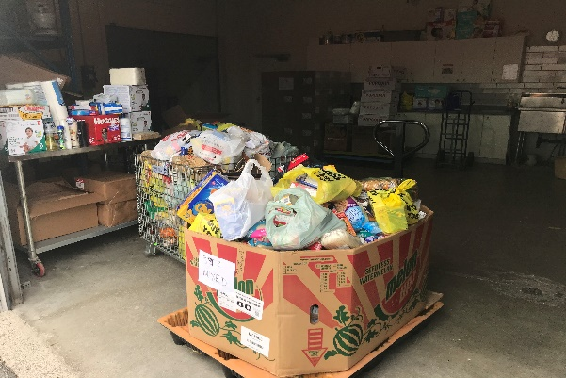
YCDSB Summer High School Program
Please see the flyer below for students in Grade 8 who are going into Grade 9. The course offered allows students to gain a credit towards the completion of their high school diploma.

Student Belongings
We have begun devising a plan for students and parents to access the school to pick-up personal belongings. We are awaiting information from York Region Public Health and look forward to sharing that plan with our community in the next few weeks.

Kindergarten Registration for 2020-2021 School Year
We continue to accept online registrations. Please visit our Holy Spirit Kindergarten Google Site for more information regarding our Kindergarten program.

School Website & Twitter
Stay connected with our Holy Spirit Website. Add us as on Twitter and tag us: @HST_YCDSB

Yours in Catholic Education,

Mr. A. Modica
Principal
anthony.modica@ycdsb.ca

