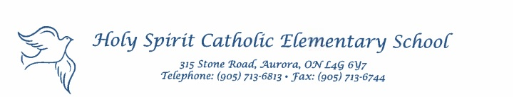
May 18, 2020

Dear Parent(s)/Guardian(s),

Happy Victoria Day! I hope everyone enjoys the opportunity to spend time with one another this holiday both in person and virtually. Please see below for some important information for our upcoming week.

Hot Lunch and Scientists in the School Refunds
All refunds for the Hot Lunch program and Scientists in the School have been sent via Canada Post.

Grade 8 Update
To our Grade 8 students and parents, I want to reassure you that many discussions are taking place to create a memorable June experience for our students. While we await more information from our school board, our Intermediate teachers and I have had several discussions on our vision to see off of our graduating students. Once details are confirmed we will communicate that directly to you through our Intermediate Google Classrooms and email.

Password Protection
In the interest of safety, students should never give their YCDSB G-Suite password to their friends and should keep them in a safe place that is not easily accessible to others. It is advised that students only share their YCDSB G-Suite password with their parent(s)/guardian(s). You may wish to change/update your child’s password. This can be done by visiting https://myid.ycdsb.ca/Change.aspx. Lastly, any time you have a technical question you can access help at https://help.ycdsb.ca/VLE/.

Aurora Teen Idol Reminder
The Aurora Teen Idol competition will take place on July 1st. This is open to all youths aged 12 to 17 in Aurora. Auditions will take place on June 10th and will be done virtually should you and your child be interested in entering the contest. The deadline to apply is June 5th. You can find more information at https://www.aurora.ca/en/recreation-arts-and-culture/canada-day.aspx

Kindergarten Registration for 2020-2021 School Year
We continue to accept online registrations please visit our Holy Spirit Kindergarten Google Site

School Website & Twitter
Stay connected with our Holy Spirit Website. Add us as on Twitter and tag us: @HST_YCDSB

Yours in Catholic Education,

Mr. A. Modica
Principal
anthony.modica@ycdsb.ca

