St. Gabriel the Archangel Catholic School


91 Fiori Drive, Woodbridge, Ontario L4L 5S4

Carnaval/Carnevale 2019
Tuesday, February 19 – Friday, February 22, 2019

St. Gabriel is enthusiastic and ready for our annual winter Carnaval/Carnevale.
Please refer to the list below for details of the daily activities planned for our school.

Theme Days
February 18 | February 19 | February 20 | February 21 | February 22
Family Day  Jour de la Famille  Monday | Tacky Tie & Tuque  Tuesday | French Mania  Mercredi | Giovedì  Gioioso  all’italiana | Vive la Nuit  Vendredi  (Civvies Day)
No school today! | Wear your tuque and    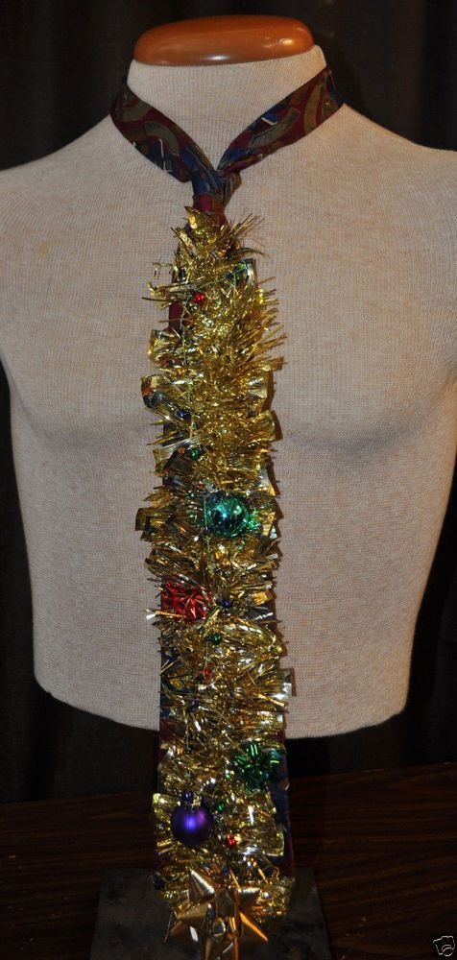  tacky tie  all day! | 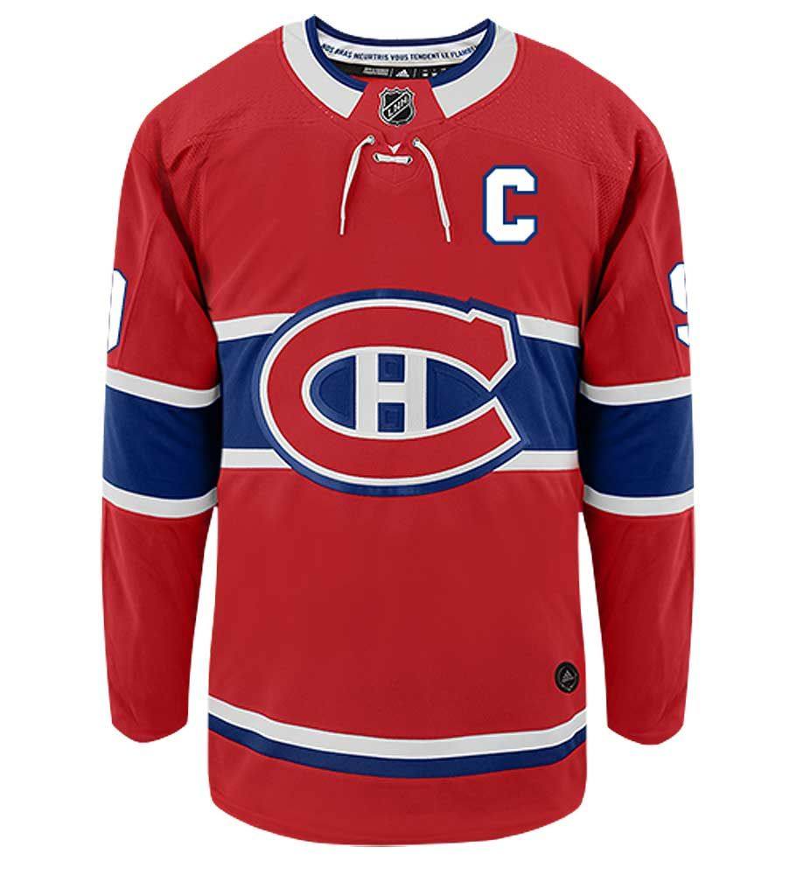  Wear French colours; blue, white & red or your Habs jersey!!! |   Wear Italian colours; green, white& red or  your Italian  jersey. | 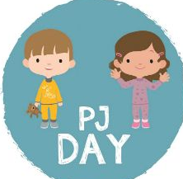  Dress in your pyjamas & slippers.  Come to  school cozy  and warm!!
Additional activities this week:
French/ Italian Prayers/Anthems
Students will say morning prayers ‘en français’ and ‘in italiano’ each day during Carnaval/Carnevale.

National Anthems will also be sung in French and Italian.

Bingo ‘en français’ and ‘in italiano’
Daily numbers will be called over the announcements.
Winning class will receive a prize.

Trivia ‘en français’ and ‘in italiano’
Winter trivia questions will be asked throughout the week!

Bonhomme and Arlecchino visits
Bonhomme & Arlecchino will visit all classes to spread good cheer and the spirit of Carnaval/Carnevale!
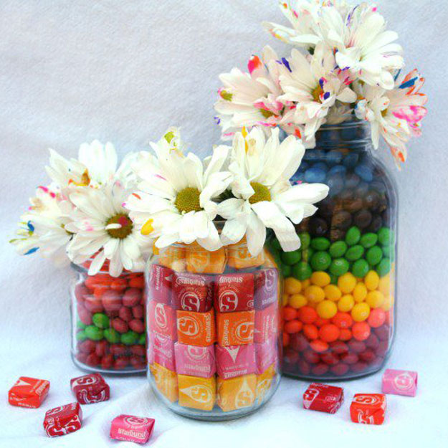
Bonbons Mania/ Candy Guessing Contest
Classes who guess the closest number of candy will be awarded a bag of candy. One winner per division (Gr.1-8)

Outdoor Activities- Vive l’hiver!!!
Attention all students! Grades 1-8, will spend one French class outdoors, weather permitting.
Students are to be dressed appropriately.

Viva il Carnevale!
Students will participate in Italian plays and mask making in Italian class.

Family Banquet Celebration (evening event)
Friday February 22th at the Premier Banquet Hall (696 Westburne Dr. Concord, On). 6:30-10:00pm Children $20, Adults $30
Thank you to our SGA Parent Council for organizing this winter event!

Bilingual French/English Performance by the “Dufflebag Theatre”
La Belle au bois dormant (Sleeping Beauty) on Wednesday Feb. 20th at 1:30pm (FDK-Gr.6)
Parents & Guardians are most welcome to join us in our school gym for the performance!

Thank you for your support and co-operation during this exciting and fun filled week!
Ms. Sandig
Mme. Paolozzi, Mme. King, Mme. Varricchio
Signora Tucciarone, Signora Ascenzi

