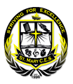
ST. MARY CATHOLIC SCHOOL
75 Greenside Drive, Nobleton, Ontario L0G 1N0 Tel: (905) 859-3336 Fax: (905) 859-3408

Dear Parents/Guardians,

Thank you for participating in the Extended Earth Hour Family Challenge. This is a friendly reminder to families that they still have this weekend to do their Earth hour and are encouraged to do even more!

Family Pledges are due next Tuesday, April 16th. Please send them with your child that day so the Eco-Team can put a display on all the efforts our St. Mary community is doing for energy conservation. Your efforts will be noted in our Ontario Eco-Schools review and hopefully, we can achieve Platinum status this year!

Thank you for your participation in our Eco-Initiatives.

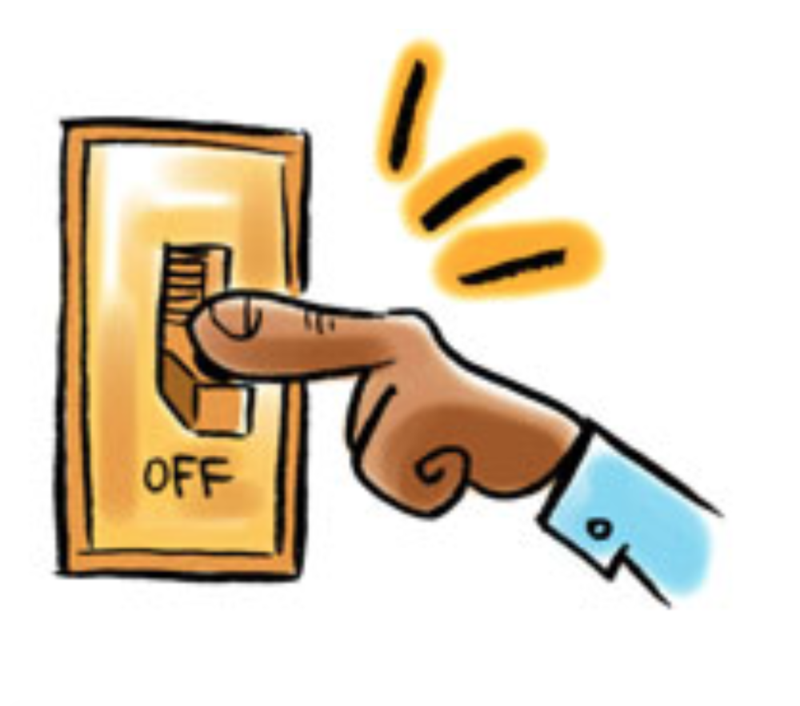

Kind regards,

St. Mary’s Eco-Team

