SAM FIORELLA – BIO

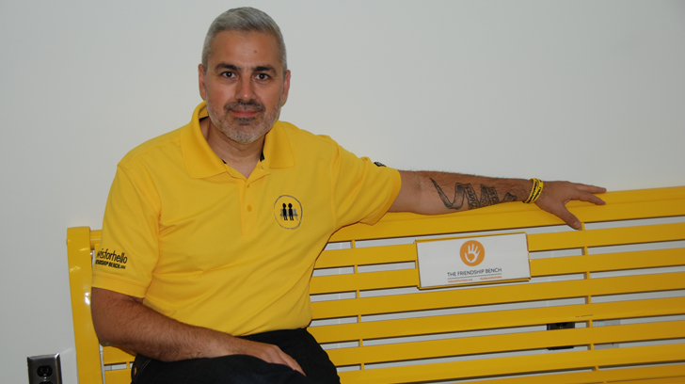
Sam Fiorella
Co-Founder and Managing Director
The Lucas Fiorella Friendship Bench #yellowisforhello

Mr. Fiorella, recipient of the Canadian Mental Health Association’s Difference Makers Award, is a highly sought after mental health advocate and keynote speaker dedicated to reducing the stigma surrounding the disease, arming young Canadians with education and resiliency skills for the modern digital age, and increasing peer-to-peer conversations about mental health.

Mr. Fiorella is the co-founder and managing director of The Lucas Fiorella Friendship Bench, a Canadian Not For Profit organization focused on decreasing mental health stigma, empowering students with education and resiliency skills for the modern digital era, and increasing peer-to-peer conversations about mental health. The campaign is now active in 60 schools across Canada – and growing each month.

The Lucas Fiorella Friendship Bench – and all the work Mr. Fiorella and his organization do – is inspired by his son Lucas, who died by suicide after years of silently suffering with depression. After his death, Lucas’s parents learned of his efforts to successfully prevent peers from attempting suicide, leaving school, or suffering from mental illness in silence.

The lessons learned from these stories – and Mr. Fiorella’s travels across the country speaking to tens of thousands of parents and students over the last 5 years – has informed his mental health advocacy, keynote presentations, and his campaign’s ongoing efforts.

Through Mr. Fiorella’s advocacy, and his organization’s #yellowisforhello campaign with it’s now iconic yellow Friendship Bench, this effort has seen an average 18% increase in the number of students asking for help in schools where the campaign is active.

STUDENT KEYNOTE - SYNOPIS

Using a storytelling approach, Sam’s keynote presentation for students does not lecture students, it educates them through the retelling of the lived experiences of other students across Canada. The presentation also does not focus on his son’s death by suicide but the lessons learned from the lives he saved.

The presentation focuses on 3 main topics:
- Painting a picture of what depression looks like through lived experience; sharing the story of his son and how he saved other students through the simple act of saying “hello,” recognizing signs that friends were in trouble, and not judging those who were suffering.
- Sharing stories told to him by thousands of students interviewed across Canada, highlighting how common anxiety, depression, and other forms of mental illness are among Canadian students. Specific focus here is the common thread among all these stories, which is despite socio-economic status, social hierarchy or other factors – all students are experiencing the same feelings.
- Factors that contribute to the increase in anxiety in the modern digital age, how it’s different than what their parents experienced, and that such increased pressures do not need to lead to drastic outcomes such as suicide attempts. Sam shares proven strategies for building resilience toolkits appropriate for students today and all unique challenges they’re facing.

